PUF FPGA Implementation Details

Abstract
Physical Unclonable Function (PUF) has been used widely for security purposes. It takes the advantage of the hardware’s manufacture variation to generate challenge-response pairs (CRPs) for authentication, secret key storage, and identification etc. FPGA serves as the most popular platform for PUF implementation. However, although the PUF circuits are not complicated, there are several important details to be taken care of in the actual implementation, otherwise the generated random numbers from PUF will not be truly random and can be retrieved by other FPGA platforms easily. This paper will explore those details which are necessary for appropriate PUF design.

- Introduction and Background
Physical Unclonable Function (PUF) is a piece of hardware that produces unpredictable responses upon challenges due to their manufacturing variations. Each PUF response is not only a function of the applied challenge, but also of the PUFs physical disorder. To apply PUF in the security field, it also needs to have the property of easy to manufacture but hard to duplicate, even under exact the same manufacturing procedures. Because of its attributions of randomness and uniqueness, PUFs can be used for random number generation (i.e. secret key generation for cryptographic purposes), authentication (i.e. IC, user, product authentication), and identification etc. PUFs can be seen as silicon fingerprints which are unique in every piece of hardware, reproducible in the same piece of hardware but not in another.
Based on how the randomness is introduced, PUFs can be categorized to PUFs using explicitly-introduced randomness such as optical PUF and coating PUF, and PUFs using intrinsic randomness such as delay PUF and memory PUF.
Based on the size of challenge-response pairs (CRPs), PUFs can be categorized as weak and strong PUFs.
- Weak PUF:
The challenge-response pair (CRP) set size grows linearly with the PUF size, mostly used for key storage. The weak PUFs usually only has one CRP, and it has to assume that the challenge-response access is secure not accessible by attackers;
- Strong PUF:
The CRP set size grows exponentially with the PUF size, mostly used for authentication. For strong PUFs there can be a large set of CRP publicly accessible. However with this large public set, it is still impossible to predicate an unknown CRP.

- Implementations of PUF
Among all the types of PUFs introduced in the previous section, we will focus mostly on the silicon PUFs for authentication with intrinsic randomness because they are easy to deploy and widely used. The two most common PUFs at presence are introduced in the following subsections: delay PUF and memory PUF. In this paper we will discuss about the FPGA implementation of the delay PUFs: Ring Oscillator (RO) PUF and Arbiter PUF.
- Ring Oscillator (RO) PUF
A RO PUF consists of two or more chains of inverters which are connected in a loop in each chain. It is obvious that each oscillator has different and unpredicted frequencies from others due to the manufacturing variation resulting in each inverter’s different delay. At the end of this circuit there are counters (of the same size) for each oscillator whose increment speed depends on the frequencies of the corresponding chains which serve as the clocks. A 1-bit RO PUF is shown in the figure below.
Fig 1. A RO PUF generating 1 bit of output.
The circuit above produces 1 bit of PUF output. The challenge will be the input selecting any two ROs from the group of N ROs, and the response is the comparison of the values in the two counters clocked by the outputs of the selected ROs. To generate more response bits with the same challenge input, more RO groups and counters can be added.
- Arbiter PUF
Arbiter PUF are multiplexer (MUX)- based. It takes two sets of MUXs connected in parallel and the output is latched by a DFF as shown in the figure below. The challenge is a binary vector whose bits 1 or 0 determines which path the input will go through. Because of the intrinsic delays in each MUX, the final output of the DFF is a random bit as in the figure. Again in this case the two parallel MUX chains should be completely symmetric in routing and placement, so that the only factor that determines the output will be the manufacturing variation.
Fig 2. An Arbiter PUF generating 1 bit of output. If the data port D receives the “1” signal first the response will be 1. Otherwise if the clock rising edge reaches to the DFF first, then the response will be 0. A stage consists of two MUXes as shown in the dotted box.

The circuit above produces 1 bit of PUF output. To generate more response bits with the same challenge input, more MUX sets and DFFs can be added.

- FPGA Implementation Problems of RO and Arbiter PUFs
Although the circuits of RO and Arbiter PUF are not of great complexity, there are some practical problems that need to be addressed before it functions correctly.

  - Combinatorial loops
Taking a closer look at a single ring oscillator (RO), it consists of odd number of inverters:
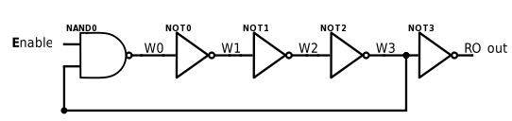
Fig 3. A ring oscillator consisting of 5 inverters

When “Enable” is set to 1, this inverter chain will produce a 1$→$0$→$1$→$0$→$1$→ ⋯$ sequence similar to a clock signal. However, since wire W3 (the output of NOT2) is fed back to the NAN0’s input pin, it forms a combinatorial loop which is not recommended by FPGA synthesis tools.

  - Logic Trim of Redundant Elements
As shown in figure 3 that a RO consists of odd number of inverters. However, this circuit logically is equivalent to a single inverter, which will be the result of synthesis’ optimization.
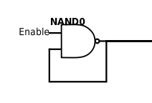
Fig. 4 A 5 stage RO is logically trimmed to a single NAND gate.

Thus we will need to preserve all the elements in synthesis and implementation.

  - Gated-clock
In the RO PUF, since the counter is clocked by a combinational logic, it forms a so-called “gated-clock”. Gated clocks can cause glitches, increased clock delay, and clock skew. Therefore designs of this type are not encouraged by the synthesizers. In some cases, it can cause a critical error preventing the synthesis or implementation process.
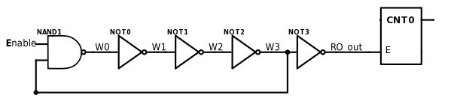
Fig 4. The counter is driven by the combinational logic of RO

Similar problem also exists in the Arbiter PUF. In Fig 2 one of the signals drives the clock port of the arbiter (DFF). Therefore critical warnings and errors will appear during the synthesis, implementation, and bitstream generation processes.
  - RO PUF: when to stop the clock?
In figure 1 the two counters will be compared against each other at a certain point. However, it cannot be any moment. The comparison needs to be made before overflow occur to the two counters. Otherwise a counter’s value at comparison point might not represent its RO’s frequency correctly.
Thus there needs to be a stopwatch module to fire the comparison signal at the right timing. The stopwatch’s period needs to be smaller than both the two counter’s overflow periods as shown in the figure below.
Fig 5. If Counter0’s RO is faster than Counter1’s, then its overflow period is smaller. When the stopwatch fires the comparison signal, Counter0 will have a larger reading than Counter1. Thus a 1 bit response can be generated by comparing the two counters’ readings.

However, if the stopwatch’s period is larger than any of the counter’s overflow period, the comparison of counter values will not correctly reflect the two RO’s speed difference.
Figure 6. If Counter1’s RO is faster than Counter0’s, then it has a smaller overflow period. However, if the stopwatch’s period is larger than Counter1’s period, then before the comparison signal is set, Counter1 has already overflown. Then when the comparison happens Counter1 may have a smaller reading than Counter0, mistakenly indicating that Counter0’s RO is faster.

Usually the stopwatch module is controlled by a real clock on FPGA. Then its period needs to be set under the knowledge of the RO frequency (counter overflow period). In addition, the stopwatch’s period also needs to large enough to reveal the ROs’ frequency difference. In one word, the frequencies of RO and the FPGA clock need to be measured and compared with.

  - Place and Route Dominates the Timing Rather Than the PUF’s Intrinsic Delay
A properly functional PUF design should generate different responses on different FPGA boards with the same HDL and configuration. However, if the routing and placement are automatically carried out by the design tools, then the timing caused by this automated process will dominate the system timing. This will result in the same CRPs on different FPGA boards.

For example, to produce one bit of response, a RO PUF will make comparison between the frequencies of two identical ROs. Although the two ROs can be instantiated from the same HDL module, after implementation they could be placed and routed very differently as shown below.
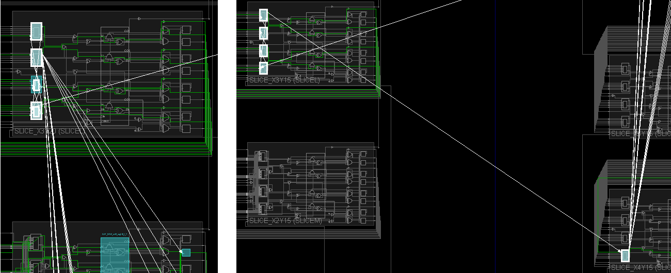
Figure 7. The 1st RO takes 4 LUTs and is placed within one site, while the 2nd RO 5 LUTs and two sites.

Therefore the frequencies of the two ROs in figure 7 are determined majorly by their different routing and placement, rather than the inverters’ (instantiated by LUTs as the FPGA’s basic element (BEL)) intrinsic manufacture difference. Due to this reason if the generated .bit file is programmed to different FPGA boards, although the responses may seem random, all the FPGAs will all have identical CRPs and so the PUFs fail to have their unique silicon fingerprints.

Similar situation also exists in the Arbiter PUFs. When the signal of “1” is propagated from one stage of two MUXes to the next in two different routes, these two routes have to be identical otherwise the routing delay will overcome the MUXes’ intrinsic delay. Moreover, at the end of the stages the two routes will enter into the clock port and the data port of the arbiter. These similarity of the two routes are even more critical since it directly determines which signal reaches to the arbiter first.

- Solutions to These Problems
In this section we will provide the suggestion solutions to the problems listed in the previous section. We will also illustrate the solutions based on Verilog HDL and Xilinx’ Vivado IDE (2015 and 2017 versions) since ISE is no longer updated since 2013.

- Combinatorial loops
To allow the RO to form a combinatorial loop, the following line can be added before the instantiation of a RO module:
- Logic Trim of Redundant Elements
To preserve the inverters in RO from being optimized away, usually the attribute of “KEEP” is used. In Vivado when a RO schematic is generated, although with the “KEEP” attribute all the inverters can be kept in the RTL schematic view which is pre-optimization, they are not in the technology view which is post-optimization from the synthesized design. The logic trim in the optimization process will still consider any even number of inverters as having no effect on chip outputs, and remove them.

In order to preserve the entire RO structure, the following attribute should be used before each inverter and wire, as well as the RO module instantiation:
It should be noted that for the RO module instantiation, it now has two attributes: “DONT_TOUCH” and “ALLOW_COMBINATORIAL_LOOPS”.

Then in both RTL and technology schematics, every component of the RO is kept:
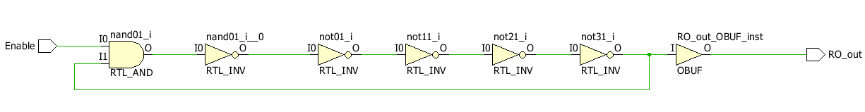
Figure 8. The RTL schematics of a 5-stage RO

Figure 9. The technology schematics of a 5-stage RO instantiated by one LUT2 (as NAND) and four LUT1 (as inverters).

To further secure the green light to allow combinatorial loops in the .bit file, a.tcl file should be created with the following tcl command:
This will set the combinatorial loop error down to a warning so that the bit stream can be written.

Then in the Vivado IDE’s Project settings -> Bitstream -> tcl.pre*, this .tcl file needs to be loaded in order to execute this setting prior to device programming.

- Gated-clock
Gated-clock can cause errors in the synthesis, implementation, and bit stream writing processes. In order to proceed with the design, the Vivado needs to downgrade the severity of this error.

Firstly a .tcl file should be created with the following tcl commands:
This will set the gated-clock error down to a warning so that the bit stream can be written.

Then in the Vivado IDE’s Project settings -> Bitstream -> tcl.pre*, this .tcl file needs to be loaded in order to execute this setting prior to device programming.

- RO PUF: when to stop the clock?
Denote the frequency of the 1st RO as f_{RO_0}, the 2nd RO as f_{RO_1}, the FPGA’s clock as f_{FPGA}, and the size of the counters as b-bits. Assume the stopwatch fires the comparison signal at the k^{th} clock cycle, to have the stopwatch module function properly as shown in Figure 5, the following statement needs to be true:
$\left( \frac{1}{f_{RO_0}}≪\frac{k}{f_{FPGA}}< \frac{2^{b}-1}{f_{RO_0}}\right) \&\& \left( \frac{1}{f_{RO_1}}≪\frac{k}{f_{FPGA}}< \frac{2^{b}-1}{f_{RO_1}}\right)$ . (1)

In (1) f_{FPGA} can be acquired from the FPGA manual.
The counter size b can be set as a large value first, say 28~32, in order to acquire a measurable overflow period. Then the MSB of the counter can be set as an output pin which connects to an oscilloscope. By observing the waveform it is not hard to calculate the overflow period, as well as the RO frequency. If the overflow period of a counter is denoted as T_{OF}, then:
$f_{RO}= \frac{2^{b}-1}{T_{OF}}$. (2)
With these parameters a proper k can be select.
The figure below shows the waveform of the MSB (the 28th bit) of a RO’s counter. Its period is 776.4ms. And so by (2) the frequency of the corresponding RO is:
$$f_{RO}= \frac{2^{28}-1}{0.7764} =345,743,759 Hz$$
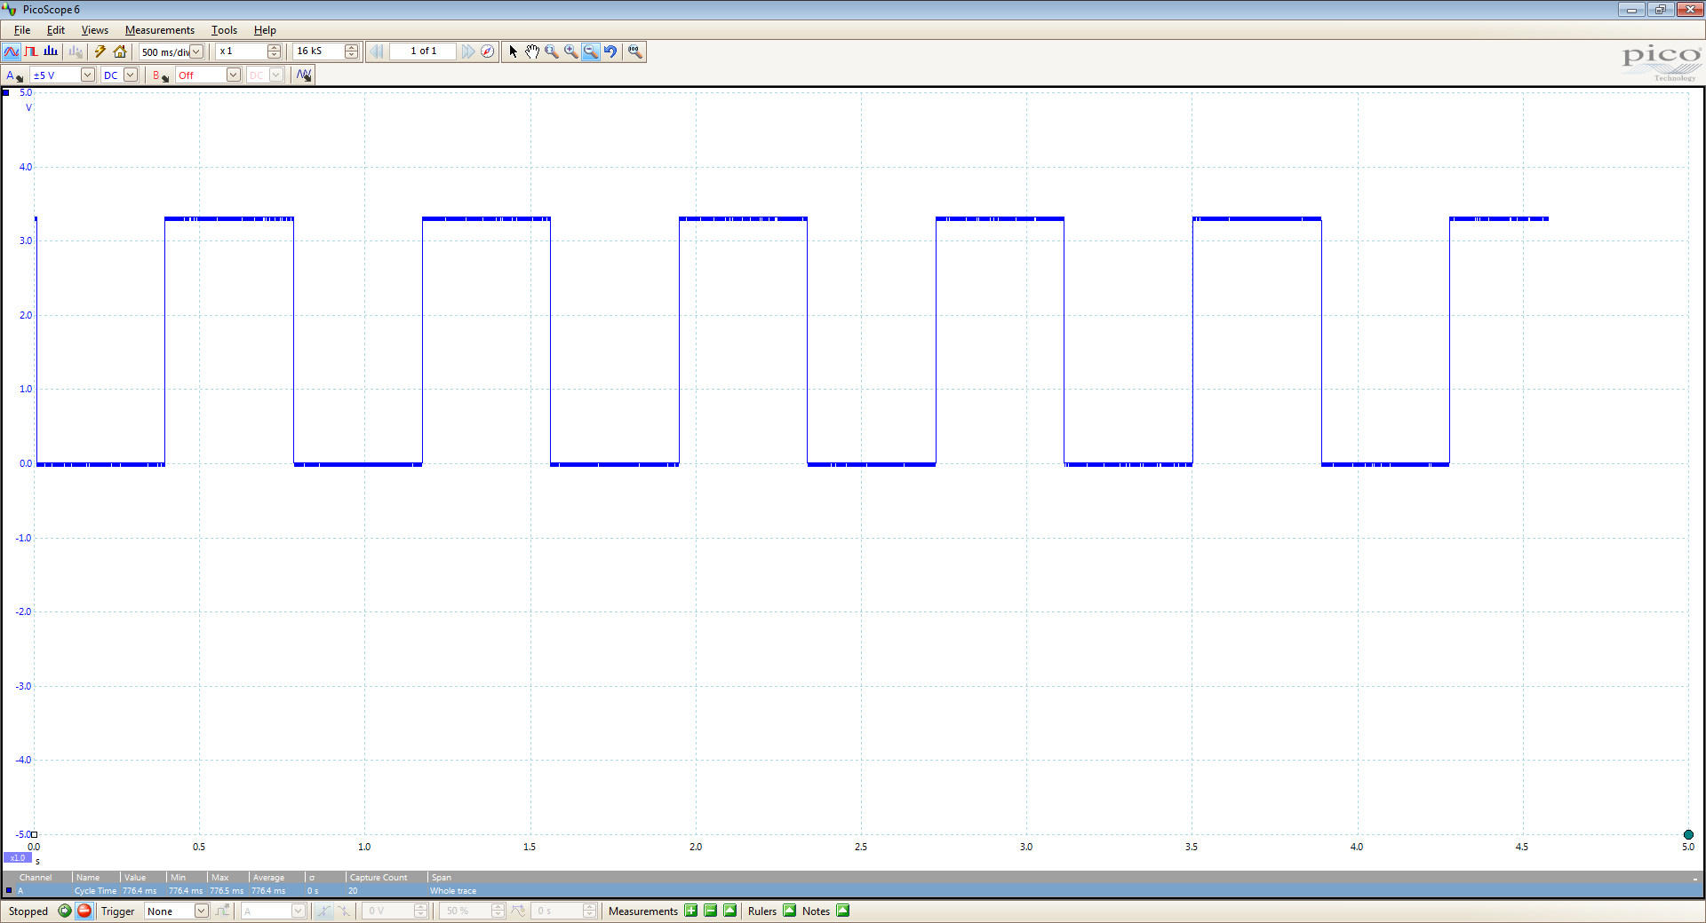|
Figure 10. The waveform of the 1st RO on a Basys3 FPGA board with period 776.4ms.
The figure below shows the waveform of the MSB (the 28th bit) of another RO’s counter. Its period is 782.5ms. And so by (2) the frequency of the 2nd RO (which is identically routed as the 1st one) is:
$$f_{RO}= \frac{2^{28}-1}{0.7825} =343,048,505 Hz$$
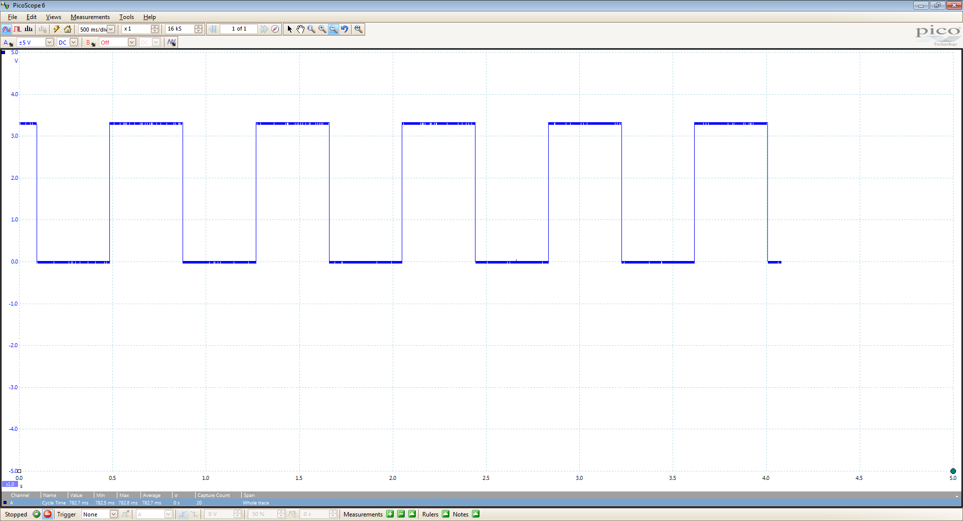
Figure 11. The waveform of the 2nd RO on a Basys3 FPGA board with period 782.7ms.
The 1st RO is faster than the 2nd RO for about 2.7 MHz and this difference will be demonstrated by the comparison of the counters.

Another better approach is to use the overflow of each counter as the comparison signal. Namely whichever counter reaches 2^{b} – 1 first, both the counters will stop incrementing and then the comparison is made. The advantage of this approach is the avoidance of using the FPGA’s clock, as well as the complication of measuring and calculating (1) and (2). The only criterion is that b should be a large enough number to reveal the RO’s frequency difference.

- Place and Route Dominates the Timing Rather Than PUF Intrinsic Delay
To eliminate the timing difference caused by place and route, all the ROs or the MUXes need to be manually placed and routed with identical placement and routing, so that the LUTs’ intrinsic delays will be the only factor making a difference in the counters.

There are three parameters to fix:
- Placement:
  - RO PUF: the 5 LUTs of each RO need to have the same relative placement;
  - Arbiter PUF: the two MUXes of each stage need to have the same relative placement;
- Pins:
  - RO PUF: since different pins inside a LUT have different speed, the pins for each LUT in each RO should be locked identically.
  - Arbiter PUF: the propagation of the signals among the stages is shown as figure 2. For the two MUXes in each stage, the signal will either be propagated from the previous stage to either both inputs 0, or both inputs 1. Therefore the inputs 0 of all MUXes should be locked to the same pin, and similarly input 1 to another pin.

- Route:
  - RO PUF: the same relative routing constraints need to be applied to all the ROs and their LUTs within;
  - Arbiter PUF: the routing from both outputs of the previous stage to both inputs 0 of the next stage should be the same, as well as the routing from the outputs of the previous stage to both inputs 1 of the next stage.
Figure 10. The routing of w1 should be the same as w2, and w3 as w4.
All the three items can be set and fixed in the .xdc constraints file.
Next we will take RO PUF as an example of the fixed place and route. Firstly, each RO’s NAND gate and 4 inverters, both instantiated by the LUTs and referred to as cells in the implementation process, should all have identical relative placement. Knowing that each Xilinx FPGA’s SLICEL (logic slice) has 4 LUT6s and 8 flip-flops, the 4 inverters for example, can be placed on those 4 LUT6s and the NAND gate on another SLICEL’s LUT6. Their relative locations also needs to be fixed for every RO, say NOT0 on BEL D5LUT, NOT1 on BEL C5LUT, NOT2 on BEL B5LUT, NOT3 on BEL A5LUT, and NAND0 on another SLICEL’s A5LUT.
The relative placement can be set through the set_property LOC and BEL keyword in the .xdc constraints file as:
Secondly, for a certain cell in all the ROs, its pins should also be locked identically. According to the Vivado constraints manual, A6 and A5 are the faster pins than A1 A2, A3, and A4.
The pins can also be set through the set_property LOCK_PINS keyword in the .xdc constraints file as:
The figure below shows two ROs with the same cell relative placement and pin locking. Each RO takes up a Complex Logic Block (CLB, consisting of two SLICELs).
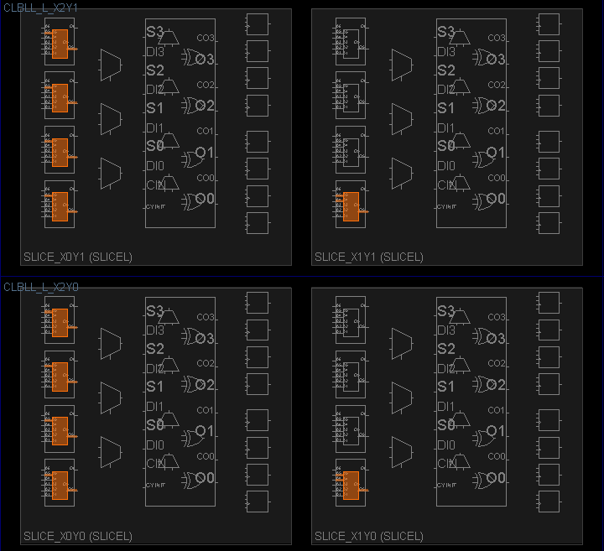
Figure 11. Two ROs with identical placements and pins.
Finally, each cell’s route needs to be fixed identically through the set_property FIXED_ROUTE keyword in the .xdc constraints file. For example, one can firstly use the following command to get the routing of wire W1 in RO_0:
And then use
to assign the same routing to W1 in RO_1. Similarly the other cell’s routing can be fixed as well. Figure 11 shows two identically routed ROs.
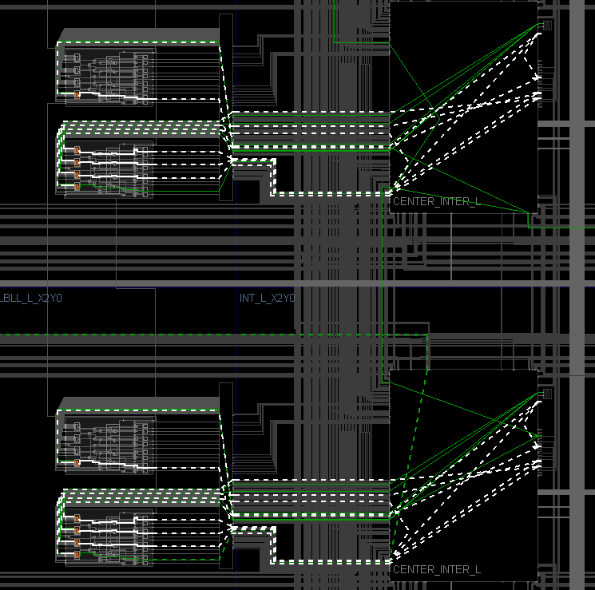
Figure 12. Two ROs with identical routing (highlighted bold white dotted lines).
For a regular PUF design there may be a large number of ROs and so using XDC Macro is an option to duplicate the fixed placement & routing from one RO to others. Once a RO’s XDC configurations are set, the following command can be used in the tcl command line to read the same setting into other ROs:
However, it should be noted that for different ROs, the absolute location property SLICE should also be different:
The other properties are relative thus can be duplicated without problems.

The Arbiter PUF can also be manually routed and places in a similar way. However, it is more complicated. For the RO PUF, each RO is more of a standalone system. As long as the routing among the five inverters of a RO is the same as the other ROs, the manufacturing variation should dominate the frequency difference among them. In the Arbiter PUF, each stage of two MUXes are connected to both MUXes of the next stage. Under this circumstance, it is almost impossible to make exactly identical routing of the wires between two stages in FPGA. This is because the slices and their components in an FPGA are not perfectly symmetrically allocated. That is to say, the placement and wiring of two neighboring slices are not mirrored. Therefore the routing can only be made as similar to each other as possible. Below is a figure showing that the routings of two MUXes from one stage to the other which are made very similarly.
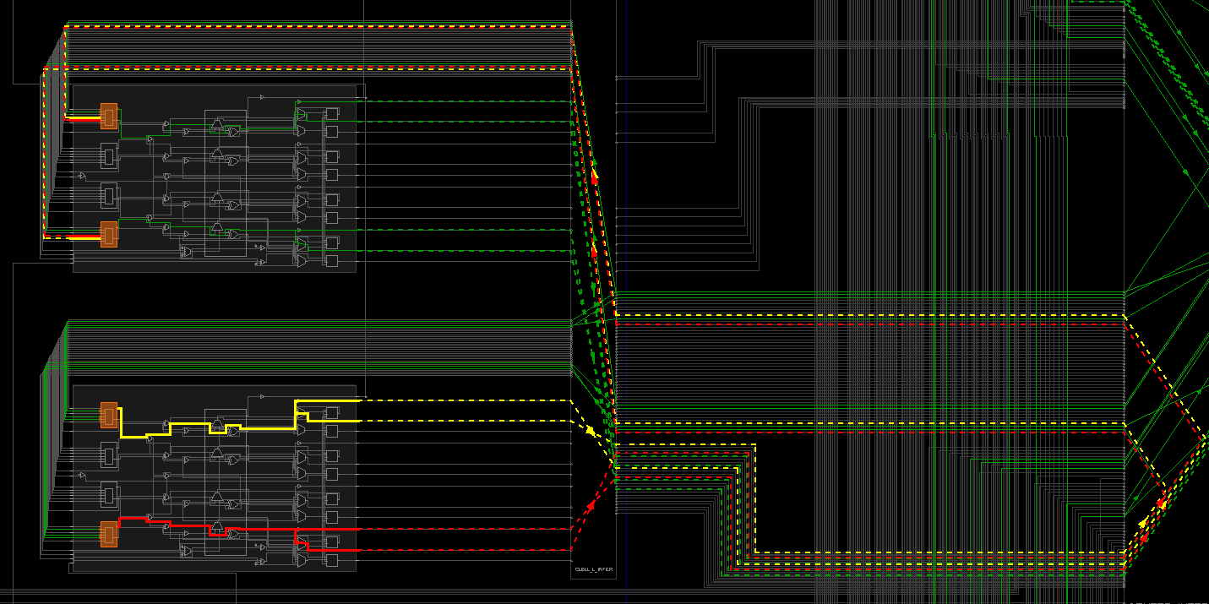
Figure 13. The routing highlighted in red is from the upper MUX of a stage to both MUXes in the next stage, and the yellow lines from the lower MUX to the next stage. The two routings are not exactly the same but are close enough to each other to minimize the delay caused by routing difference.

In addition, the RO PUF’s routing can be easily carried out by acquiring one RO’s routing and then duplicate to another using tcl commands or xdc constraints. But the Arbiter PUF’s routing between stages has to be manually chosen and fixed in order to achieve as much symmetry as possible. However, although an FPGA provides many routing options from one cell to another, the routing path cannot be “invented” by simply editing the xdc constraints. It has to be explored using the “Assign Routing Mode”.
To do so, one can follow the steps below and we will use the notations in Figure 10 for better illustration.
- Firstly the placement and pin of two stages of MUXes (4 MUXes) can be fixed according to the rules in section E (1) and (2) using xdc constraints.
- Then, after running the implementation, in the “Device” tab w1 can be highlighted. By right clicking on w1, a menu will pop up from where we can select “Unroute” to cancel the current routing of the wire. By right clicking on w1 again we can select “Enter assign routing mode…”. This will enable us to manually route w1.
- After choosing the “Enter assign routing mode …”, we will be asked if we want to set the routing target/destination or not. In figure 10 it refers to pin 0 of the lower MUX and pin 1 of the upper MUX in stage 2. We can either select a target pin to route to that destination, or choose “No load” to explore all possible options of routing to any cell and any pin.
- If a load (target) is selected, then a menu named “Routing Assignment” will appear on the right hand side of the device window. By clicking on the first item (node) under “Assigned Nodes”, the next possible nodes will show up in dotted lines, from which we can set the routing path node by node, and finally to our target. We can also right click on any node in the “Assigned Nodes” window to remove them from the path.
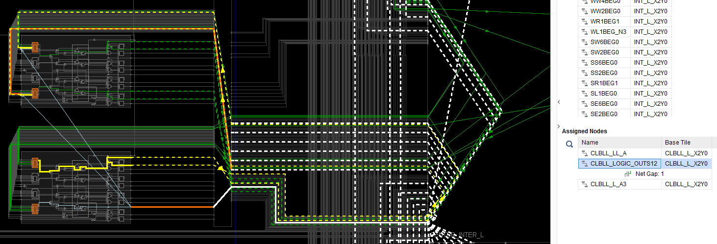
Figure 14. All the dotted lines represent the next possible nodes following the node “CLBLL_LOGIC_OUTS12”, which is highlighted in the “Assigned Nodes” menu. By selecting the nodes one by one, we can route the output of a MUX to the inputs of the two MUXes in the following stage with our desired path.

- When the wire is finally routed to the target, all the newly routed path will be displayed in orange and the “Net Gap” will disappear from the “Assign Nodes” window.
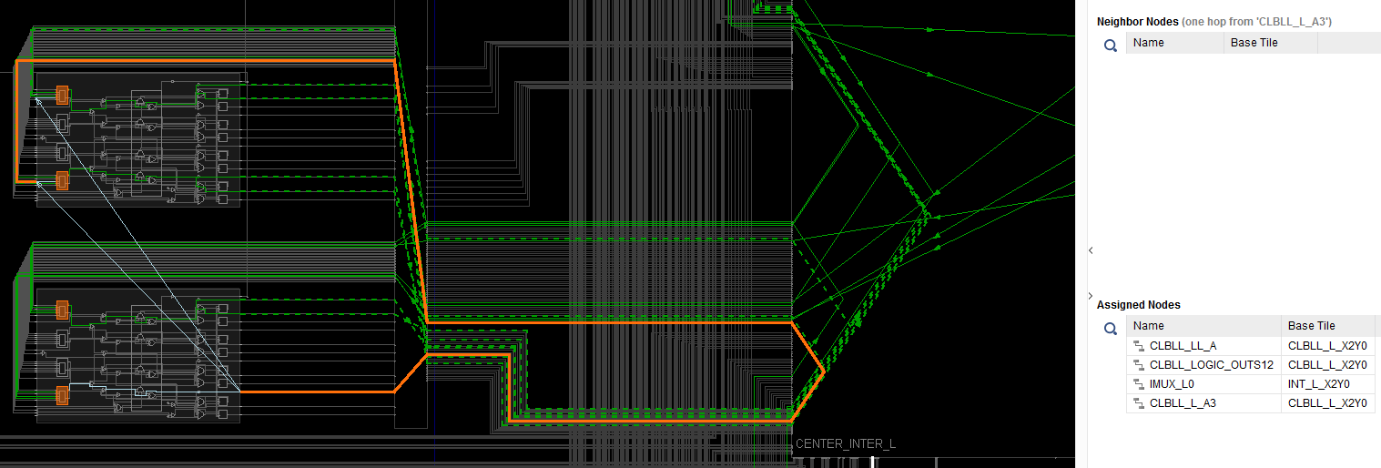
Figure 15. The w1 is successfully routed to the input pin 0 of a MUX in the next stage via the orange path.

- Then we can continue to route w2 in a similar route to minimize the delay difference caused by different routing.
- After w1, w2, w3, w4 are all routed, their routing path can be read out by:
get_property ROUTE [get_nets w1]
which can be applied to the next stage’s routing using xdc constraints.

- System Overviews of the RO and Arbiter PUFs

  - System charts for a Power-saving RO PUF
To save power on a RO PUF, the Challenge bits can also work as the Enable signal which only enables the selected RO chains.
Figure 14. A RO PUF with k-bit responses consisting of k groups of RO chains. From every group each time two ROs will be enabled and selected to compare by the challenge input. The comparison is triggered by the overflow of either counter in a group.

  - Toy Examples of RO and Arbiter PUFs
The figure below shows a toy example of a 4-bit RO PUF with 1 CRP. The identical design is programmed to multiple FPGAs with the same model and results in different responses:
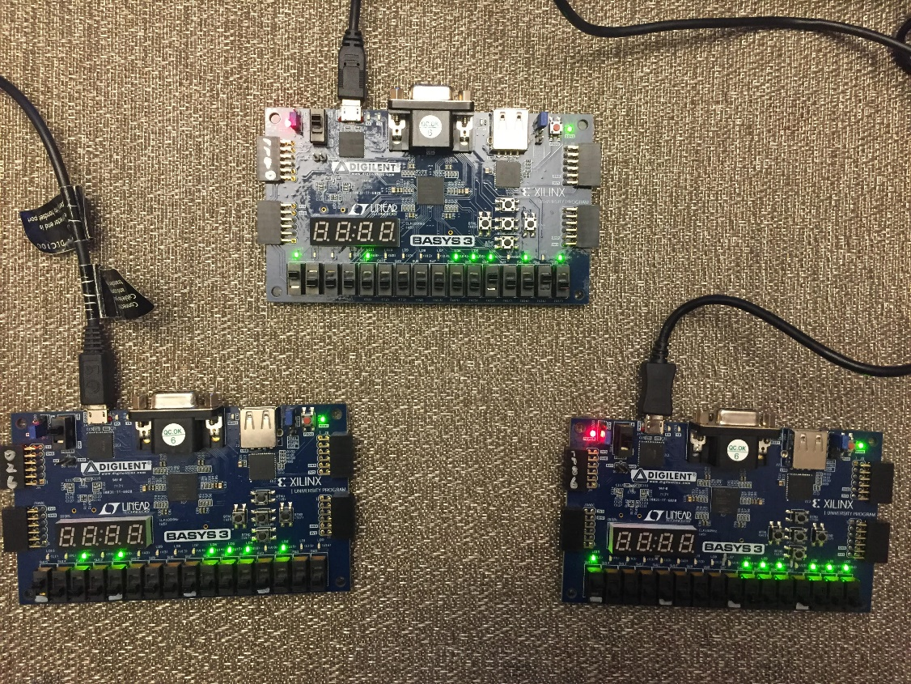
Figure 15. Three FPGAs with different 4-bit responses by the same RO PUF design

The figure below shows a toy example of an 8-bit Arbiter PUF with 2⁸ CRPS. The identical design is programmed to multiple FPGAs with the same model and results in different responses:
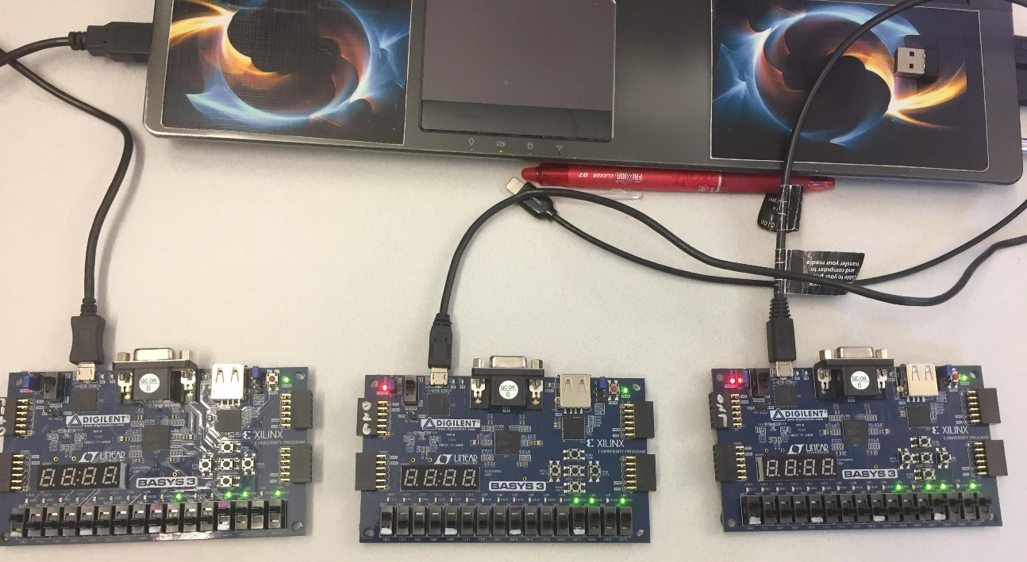
Figure 16. Three FPGAs with different 8-bit responses by the same Arbiter PUF design

